Project Design Phase Solution Architecture

Date | 26 June 2025
Team ID | LTVIP2025TMID53093
Project Name | HouseHunt: Finding Your Perfect Rent  al Home
Maximum Marks | 4 Marks

Solution Architecture – HouseHunt
HouseHunt follows a modern web-based architecture using the MERN stack (MongoDB, Express, React, Node.js). It ensures a scalable, secure, and real-time rental listing experience through a modular, API-driven design.
Goals of the Architecture:

- Ensure scalability as user base grows
- Provide fast and secure data access
- Maintain modular design for easy updates
- Enable real-time communication (chat/call)
- Ensure mobile-first responsiveness
- Offer clean separation between frontend, backend, and database

Solution Architecture Diagram:
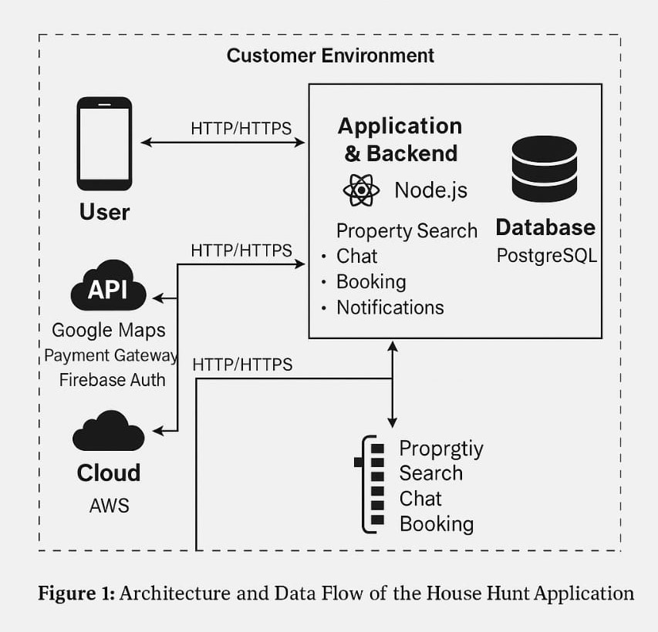
Figure 1: Architecture and Data Flow of the HouseHunt Application

Key Architecture Components:

Layer | Technologies / Responsibilities
Frontend | Built using React.js, styled with Material UI and Bootstrap for responsive design.
Backend | Developed in Node.js with Express.js, responsible for APIs, routing, authentication, etc.
Database | MongoDB for storing users, bookings , properties, in structured collections.
Authentication | JWT based secure login for renters, owners, and admins.
Real-time Chat | Enabled via Socket.IO to allow users and agents to communicate on complaint threads.
Email/SMS Alerts | Uses Nodemailer and optionally Twilio for notifications and updates.
Hosting | Frontend and backend can be deployed on Vercel, Render, or MongoDB Atlas (cloud DB).

Reference

AWS Blog – Voice Applications in Clinical Research (Architecture and Design Considerations)
https://aws.amazon.com/blogs/industries/voice-applications-in-clinical-research-powered- by-ai-on-aws-part-1-architecture-and-design-considerations/

